

|  |
| --- |
| SELF CHECKOUT SHOPPING CART |
| BY |
| SIDDHANT JAJOO |
| SATYA MEHTA  DEEPESH SONIGRA |

**UNDER THE GUIDANCE OF:**

PROFESSOR TIMOTHY SCHERR, RANDALL SPALDING UNIVERSITY OF COLORADO BOULDER

11/2/2019

**TEAM NAME: ASHWATHAMA**

### LOW POWER EMBEDDED DESIGN TECHNIQUES| ECEN 5833 | FALL 2019

**TABLE OF CONTENTS**

INTRODUCTION 2

PROBLEMS FACED 2

SOLUTIONS 2

FUNCTIONAL BLOCK DIAGRAM 3

BOARD BLOCK DIAGRAM 4

BOARD BLOCK DIAGRAM WITH PMU 4

FEATURES 5

GOALS ACCOMPLISHED PAST WEEK 6

GOALS PLANNED FOR NEXT WEEK 6

UPDATES Error! Bookmark not defined.

COMPONENT SELECTION 8

SPECIFICATIONS 10

POWER MANAGEMENT UNIT 11

OVERVIEW 11

* 1. ATE OF THE SPECIFIED LIPO BATTERY: 12

I2C TIMING ANALYSIS 13

PEAK DISCHARGE CURRENT 14

RECHARGE TIME ANALYSIS 14

BATTERY CYCLES 14

CHARGE/DISCHARGE CYCLES 14

BULK CAPACITANCE 16

ENERGY STORAGE ELEMENT 18

USE CASE MODEL 19

ENERGY MODES 24

AVERAGE DC CURRENT MATH 25

HIGH RISK DEVELOPMENT AREAS 27

FUTURE SCOPE 27

### LOW POWER EMBEDDED DESIGN TECHNIQUES| ECEN 5833 | FALL 2019

# INTRODUCTION

The “Self-Checkout Shopping Cart” is an innovative consumer purchasing product that is designed to help shoppers fast-track their shopping experience! The shopping cart has an inbuilt barcode scanner which can be used to scan the items to be purchased. The device communicates with the phone over the Bluetooth and bill is generated based on the items. Android app can be used for payment and faster checkout. With the advent of energy efficient devices and low power nodes, it has become imperative to design boards that consume low power which can last longer. To that end, we are designing nodes in order to consume minimal energy and address the issues mentioned below.

# PROBLEMS FACED

* + 1. Customers usually get annoyed because of the long queues in the billing section of the huge shopping markets.
    2. In addition to that keeping track of all the bills and budget is a very burdensome task.
    3. Usage of lot of manpower in large supermarkets which can be expensive.
    4. Stock management in supermarkets.

All these problems could be addressed by our “Self-Checkout Shopping Cart”.

# SOLUTIONS

1. Fast self-checkout saves time of customers and helps them buy items according to their budget.
2. Electronic bill is generated and saved in the cloud which makes it easy to keep track of all the bills and saves paper.
3. By letting customers handle their own scanning and bagging, workers can spend their time helping customers find what they need.
4. Better shopping experience for the customers and an innovative way for the sellers to attract customers.

### LOW POWER EMBEDDED DESIGN TECHNIQUES| ECEN 5833 | FALL 2019

# FUNCTIONAL BLOCK DIAGRAM

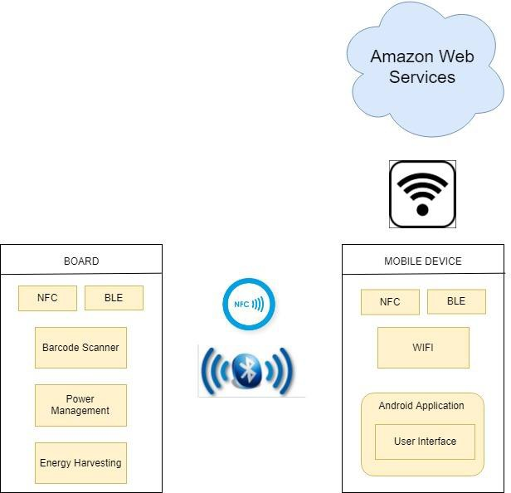

**LOW POWER EMBEDDED DESIGN TECHNIQUES| ECEN 5833 | FALL 2019**

# BOARD BLOCK DIAGRAM

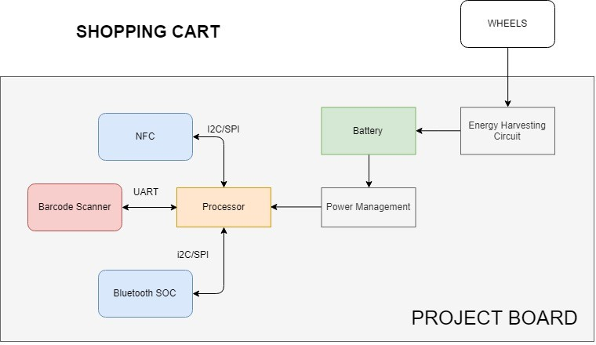

# BOARD BLOCK DIAGRAM WITH PMU

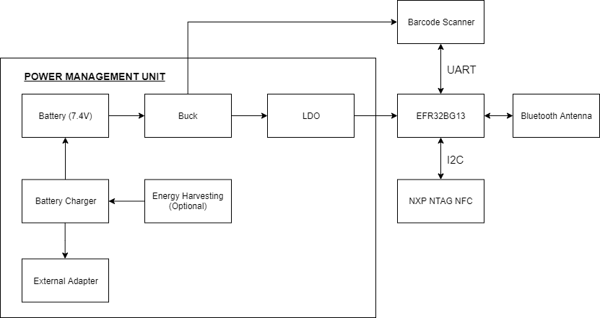

**LOW POWER EMBEDDED DESIGN TECHNIQUES| ECEN 5833 | FALL 2019**

# FEATURES

* The device connects with the mobile using Bluetooth with Bluetooth authentication done using NFC for faster and secure connection.
* The device is battery operated with the capability of energy harvesting (optional) from the movement of the wheels.
* The Android application is capable of displaying all the scanned items and total price of the items in the cart.
* The Android application pushes data to the cloud to keep track of past bills and calculate the amount spent in certain time frame.

### LOW POWER EMBEDDED DESIGN TECHNIQUES| ECEN 5833 | FALL 2019

# GOALS ACCOMPLISHED PAST WEEK

|  |  |  |  |
| --- | --- | --- | --- |
| **SR.**  **NO.** | **TASK** | **DESCRIPTION** | **STATUS** |
| 1 | Layout Design | Approved | Completed |
| 2 | Sensor Integration | Barcode Scanner UART driver | Completed |
| 3 | NFC Integration | I2C Interface | Completed |
| 4 | Ordering PCB | PCBWay and Wufoo | In Process |
| 4 | Android App | Bluetooth Functionality | In Process |

# GOALS PLANNED FOR NEXT WEEK

|  |  |  |  |
| --- | --- | --- | --- |
| **SR.**  **NO.** | **TASK** | **DESCRIPTION** | **STATUS** |
| 1 | Battery Charger Testing | Test Battery management evaluation kit with batteries | NA |
| 2 | Firmware | Full Application Development | NA |

### LOW POWER EMBEDDED DESIGN TECHNIQUES| ECEN 5833 | FALL 2019

# COMPONENT SELECTION

1. **Processor - Blue Gecko EFR32BG13:** This is a processor (SOC) sold by Silicon Labs, which has Bluetooth stack built into it with peripherals such as I2C, SPI, UART and 31 GPIO pins. This processor would serve as a controller for the entire system and would also be responsible for executing commands related to the Bluetooth stack. The SOC supports low energy modes and has provisions for load power management (i.e EM0, EM1, EM2, EM3, EM4) thus making it the appropriate choice for a low power project.

The EFR32BG13 Blue Gecko Bluetooth Low Energy SOC Family Data sheet can be found here - <https://www.silabs.com/documents/public/data-sheets/efr32bg13-datasheet.pdf> Reference Manual: [https://www.silabs.com/documents/public/reference-manuals/efr32xg13-](https://www.silabs.com/documents/public/reference-manuals/efr32xg13-rm.pdf) [rm.pdf](https://www.silabs.com/documents/public/reference-manuals/efr32xg13-rm.pdf)

Mouser Link to purchase: Purchase [here](https://www.mouser.com/ProductDetail/Silicon-Labs/EFR32BG13P732F512GM48-D?qs=sGAEpiMZZMuReUCzg6bfTAYlATJbN4Oc5QTtA8qQDVJzoYCcTOwW2w%3D%3D)

The Blue gecko to be used for this project is: EFR32BG13P632F512GM48-D.

1. **NFC Module - NXP NTAG NFC Module:** This NFC module would be used for hands-free quick Bluetooth pairing authentication between the cart and the mobile phone. The interface used for NFC module is I2C which is available in the processor selected above. This module can interact with an NFC device as well as unpowered NFC chips such as tags, stickers, key fobs and cards which do not require batteries. This module also has the NFC energy harvesting capability if required. The module also consists of different modes for energy saving purposes.

Digikey Link to purchase: Purchase [here](https://www.digikey.com/product-detail/en/nxp-usa-inc/OM5569-NT322EM/568-12907-ND/5872984)

The datasheet for this module can be found here: <https://www.nxp.com/docs/en/data-sheet/NT3H2111_2211.pdf>

1. **Sensor - Barcode Scanner:** This barcode scanner was chosen because it gave us the lowest sleep mode current in comparison to all the other bar code scanners. It consists of a USB and UART interface. The module has different modes such as sleep, standby and scanning modes for load power management. There are very small amounts of portable barcode scanners available in the market which consume low current and most of them support UART or RS232 interface. Thus, we did not have much flexibility in choosing an interface for the barcode scanner.

Link to purchase: Purchase [here](https://www.waveshare.com/barcode-scanner-module.html)

The user manual/datasheet for this module can be found here: [https://www.waveshare.com/w/upload/3/3c/Barcode_Scanner_Module_User_Manual](https://www.waveshare.com/w/upload/3/3c/Barcode_Scanner_Module_User_Manual_EN.pdf)

[_EN.pdf](https://www.waveshare.com/w/upload/3/3c/Barcode_Scanner_Module_User_Manual_EN.pdf)

1. **Energy Storage Element: Battery - Lipo Lithium Ion battery:** Since our sensor operates on 5V, it made sense to have a battery whose voltage level is more than 5V. The battery has a 1000mAh capacity. This battery is a dual cell battery which consists of two 3.7V

### LOW POWER EMBEDDED DESIGN TECHNIQUES| ECEN 5833 | FALL 2019

cells in series. This battery specification is subject to modifications as per the power calculations in subsequent weeks.

Sparkfun Link to purchase: Purchase [here](https://www.sparkfun.com/products/11855)

Battery Manual: <https://cdn.sparkfun.com/datasheets/Prototyping/Lithium%20Ion%20Battery%20MSDS.pdf>

1. **Power Management IC:**
   1. Buck Converter (TPS560430XFDBVR) -

The battery specified above has a maximum voltage rating of 7.4 voltage and can drop till a minimum of 6 volts for the system to remain operational. The Barcode Scanner sensor would require a rail voltage of 5V. Thus, it is required to have a buck converter and not a buck-boost converter since the voltage would never drop below 5V. The buck converter would be able to provide a rail voltage of 5V at battery voltages above 5V.

Digikey Link to purchase: Purchase [here](https://www.digikey.com/product-detail/en/texas-instruments/TPS560430XFDBVR/296-52607-1-ND/9860387) Datasheet:

[http://www.ti.com/general/docs/suppproductinfo.tsp?distId=10&gotoUrl=http%3A%2F](http://www.ti.com/general/docs/suppproductinfo.tsp?distId=10&gotoUrl=http%3A%2F%2Fwww.ti.com%2Flit%2Fgpn%2Ftps560430)

[%2Fwww.ti.com%2Flit%2Fgpn%2Ftps560430](http://www.ti.com/general/docs/suppproductinfo.tsp?distId=10&gotoUrl=http%3A%2F%2Fwww.ti.com%2Flit%2Fgpn%2Ftps560430)

* 1. Low Dropout Voltage Regulator (LDO) (LM117) -

The NXP NTAG - NFC reader and the processor have an operating voltage 0V- 4.6V and 1.8V-3.8V respectively. Since the minimum operating voltage for the battery is 4V, it was apt to use an LDO or a buck converter instead of a buck- boost converter to generate a rail voltage of 3.3V. Voltage dropout consideration is not required in this case as there is a wide gap between the minimum operating battery voltage and the rail voltage required by barcode sensor. In terms of efficiency for our application, the LDO provides a respectable efficiency as compared to a buck converter. Since the LDO provides the smallest solution footprint and is the cheapest option, LDO was selected in order to obtain a 3.3V for the barcode sensor.

Digikey Link to purchase: Purchase [here](https://www.digikey.com/product-detail/en/texas-instruments/LM1117MPX-3.3-NOPB/LM1117MPX-3.3-NOPBCT-ND/1010516) Datasheet:

[http://www.ti.com/general/docs/suppproductinfo.tsp?distId=10&gotoUrl=http%3A%2F](http://www.ti.com/general/docs/suppproductinfo.tsp?distId=10&gotoUrl=http%3A%2F%2Fwww.ti.com%2Flit%2Fgpn%2Flm1117)

[%2Fwww.ti.com%2Flit%2Fgpn%2Flm1117](http://www.ti.com/general/docs/suppproductinfo.tsp?distId=10&gotoUrl=http%3A%2F%2Fwww.ti.com%2Flit%2Fgpn%2Flm1117)

* 1. Battery Charge Management IC (MCP73213) -

The MCP73213 is a highly integrated Li-Ion battery charge management controller for use in space-limited and cost-sensitive applications. This IC would be required in order to charge the Lipo battery using energy harvesting methods or using USB. Since charging requires a constant current and voltage across the

### LOW POWER EMBEDDED DESIGN TECHNIQUES| ECEN 5833 | FALL 2019

battery, it is imperative to use an IC which provides regulated voltage and current. In addition to this, the 7.4V battery would require voltage greater than 7.4V for charging it. This IC would convert the 5V supplied by the USB to Output Voltage options such as 8.20V, 8.4V, 8.7V, 8.8V. This IC support fast charging mode which can charge 7.4V battery by sourcing current upto 1100mA which can fully charge our battery in an hour.

Digikey Link to purchase: Purchase [here](https://www.digikey.com/product-detail/en/microchip-technology/MCP73213T-A6BI-MF/MCP73213T-A6BI-MFCT-ND/7898468)

Datasheet: <http://ww1.microchip.com/downloads/en/devicedoc/20002190c.pdf>

# SPECIFICATIONS

1. Processor (SOC) - Blue Gecko EFR32BG13P732F512GM48-D, Operating Voltage: 1.8V- 3.8V freq band: 2.4 Ghz@19 dBm, Flash: 512kB, RAM: 64kB, GPIO: 31, Operating Range:

-40°C to 85°C

1. NFC Module: Working Voltage: Baud Rate: 115200 bps, Operating Voltage: 0V-4.6V, Operating range: 2 to 5 cm, Size: 11cm x 5cm
2. Sensor-Barcode Scanner: Operating Voltage: 5V, Operating Temperature: 0°C - 50°C, Size: 53.3mm x 21.4mm
3. Buck Converter: Input Voltage Range: 4V to 36V, Output Voltage: 2.5V to 9V, 2A output current in buck mode, Size: 2.90mm x 1.60mm
4. Low Dropout Voltage Regulator (LDO): Output Voltage: 3.3V, Output Current: 800mA, Size: 6.50mm x 3.50mm
5. Battery Charge Management IC (MCP73213): Battery Charge Voltage Option: 8.20V, 8.4V, 8.7V, 8.8V, fast charge current: 130mA -1100mA, Size: 3mm x 3mm.
6. Battery - Weight: 85g, Size: 70mm x 35mm x 18mm
7. Dimensions: 120mm x 50mm (Approx)
8. Battery: 7V Battery (1) - Rechargeable
9. Wireless Range: 60 meters /180ft
10. Temperature Range: 0 - 50°C
11. Temperature Accuracy: Typical: ±0.3°C /± 0.5°F, Max: ±0.5°C /±0.9°F3
12. Humidity Range: 0~99%RH
13. Humidity Accuracy (25°C/ 77°F, 20%~80%RH): Typical: ±3%RH, Max: ±4.5%RH
14. Warranty: 2-3 years.

### LOW POWER EMBEDDED DESIGN TECHNIQUES| ECEN 5833 | FALL 2019

# POWER MANAGEMENT UNIT

OVERVIEW

The Power management unit would consist of a circuitry to supply regulated power supply since the barcode scanner requires a rail voltage of 5V, NXP NTAG requires a voltage of 0V-4.6V and processor requires a voltage between 1.8V-3.6V. Thus, NXP NTAG and the processor have wide voltage inputs. The operating voltages of all the ICs have been specified in the specifications section. In order to generate all the rail voltages according to different sensors and processor input voltage requirements, buck and LDO is required.

The battery specified above has a maximum voltage rating of 7.4V and can drop till a minimum of 6 volts for the system to remain operational. The Barcode Scanner sensor would require a rail voltage of 5V. Thus, it is required to have a buck converter in order to improve the battery life of the system. The buck converter would be able to provide a rail voltage of 5V at battery voltages above 5V.

LDO would be required for NXP NTAG – NFC and the processor as their operating voltages are predominantly below 4V. The LDO would be attached in series with the Buck converter in order to convert the 5V obtained from the Buck converter to 3.3V for the NXP NTAG and the EFR32BG13 processor.

There were two possible options to obtain the 5V and 3.3V from the power supply:

1. Having the buck and LDO in parallel and generating the rail voltages independently.
2. Having Buck and LDO in series so that the LDO generates a rail voltage of 3.3V following the buck converter which generates 5V.

The first option dissipated a lot of heat as compared to the second one. Reducing the voltage is done at the expense of heat, the LDO drop from 7.4V to 3.3V proved to be a lot expensive in terms of power dissipation. The efficiency of LDO was not even 50% which implied that the heat dissipation would require a large heat sink as well. Assuming the efficiency of Buck to be 80%, we did come up with some numbers to justify the series connection. The calculations are done for constant power mode, so we assume current values to demonstrate the selection.

### In case of parallel connection:

In case of Buck (Output Voltage = 5V):

Assuming buck output voltage of 5V and a current of 2mA, Power output required = V*I

= 5*2 = 10uW.

Assuming 80% efficiency for the buck converter, the input power required would be 10/0.8 = 12.5uW. Thus 12.5uW = 7.4V x 1.6 mA.

### LOW POWER EMBEDDED DESIGN TECHNIQUES| ECEN 5833 | FALL 2019

Thus, extra power required would be 12.5 – 10.0 = 2.5 uW.

Now for LDO (Output Voltage = 3.3V):

Assuming the current to be 3.5mA, Power output required = V*I = 3.3V * 3.5mA = 11.55 uW.

Similarly Input Power = 7.4V * 3.5 mA = 25.9 uW.

Thus, extra power required would be 25.9 – 11.55 = 14.35 uW. Thus, the total power lost in heat would be 14.35 + 2.5 = 16.85 uW.

### In case of series Connection:

In case of Buck (Output Voltage = 5V):

Assuming buck output voltage of 5V and a current of (2 + 3.5)mA, Power Output required = V*I = 5*5.5 = 27.5uW.

Assuming 80% efficiency for the buck converter, the input power required would be 27.5/0.8 = 34.35uW. This 34.35uW = 7.4V x 4.64 mA. 4.64mA would be the input current.

Thus, extra power required would be 34.35 – 27.5 = 6.85 uW.

Now for LDO (Output Voltage = 3.3V):

Assuming the current to be 3.5mA, Power output required = 3.3V * 3.5mA = 11.55 uW. Similarly Input Power = 5V * 3.5 mA = 17.5 uW.

Thus, extra power required would be 17.5 – 11.55 = 5.95 uW. Thus, the total power lost in heat would be 6.85 + 5.95 = 12.8 uW.

As you can see the power lost in case of parallel connection is 16.85 uW and in case of series connection is 12.8 uW. This proves that the power lost in series connection is less than the parallel connection. In addition to this, the total input power required is 38.4 uW and 34.35 uW for parallel and series connection respectively.

Thus, it is clear that series connection is better than the parallel connection in terms of power dissipation.

C-RATE OF THE SPECIFIED LIPO BATTERY**:**

C-Rate is used to express the magnitude of the charge or discharge current; expressed as a multiple of the battery rated capacity multiplied by the current. In general, the charge or discharge current is expressed as a multiple of C.

### LOW POWER EMBEDDED DESIGN TECHNIQUES| ECEN 5833 | FALL 2019

C-Rate = Average current/Battery Capacity = 9.08mA / 1000 mah = 0.0908 C

Peak discharge rate out of battery:

Peak Current/Battery Capacity = 138.195 (Mode 4)/1000 = 0.138 C

Based on our lithium battery discharge curve, the lowest nominal voltage is 7.2V. The battery cut off voltage of our circuit is 6V.

This nominal voltage will require a buck only solution.

* 1. V will be programmed as the cut off voltage from the battery of the PMU circuit.

The difference between the nominal and programmed voltage is due to the voltage drop across the buck converter.

The battery specified above has a maximum voltage rating of 7.4 voltage and can drop till a minimum of 6 volts for the system to remain operational. The Barcode scanner sensor would require a rail voltage of 5V. Thus, it is required to have a buck converter and not a buck-boost converter since the voltage would never drop below 5V. The buck converter would be able to provide a rail voltage of 5V at battery voltages above 5V.

I2C TIMING ANALYSIS

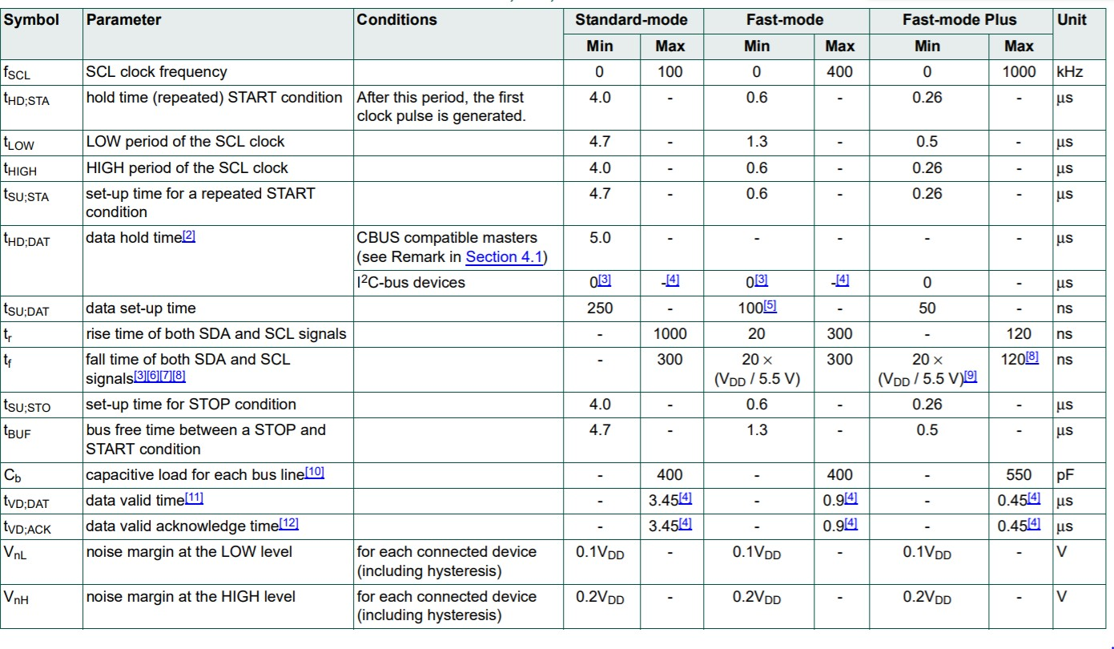I2C timing table as found in the NXP NTAG datasheet:

### LOW POWER EMBEDDED DESIGN TECHNIQUES| ECEN 5833 | FALL 2019

Time required for 1 I2C transmission for 1 packet = tsetup_start + tdata/ack + trise + tfall + tdata/ack + tdata_hold + tsetup_stop = (4.7 + 3.45 + 1.3 + 3.45 + 5 + 4) us = 21.9 us.

For UART, the baudrate chosen is 9600 since we would be using the LEUART peripheral of EFR32BG13 which runs at a baudrate of 9600.

PEAK DISCHARGE CURRENT

The battery chosen is capable of providing the peak discharge current as specified in the datasheet which is 0.5C which is equal to 500 mA and our peak current is 170mA.

RECHARGE TIME ANALYSIS

Standard charge time for charging cells to their rated capacity is 2.5 hours at a charging voltage of 4.20 V/cell and charging current of 1C.

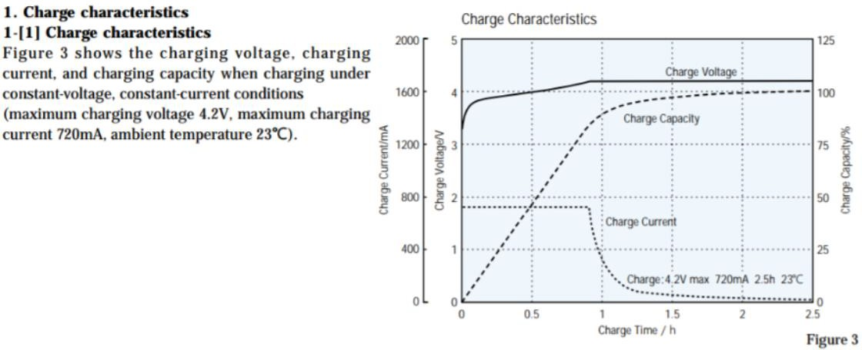

Shows for single cell. We will charge with 8.4V and 500mA current constant.

BATTERY CYCLES

Battery should last more than 500 charge cycles if used under given charge/discharge specifications.

## CHARGE/DISCHARGE CYCLES

We are planning to use 80% (800mAh) of the battery storage per discharge cycle. The voltage drops to around 3V/Cell that is 6V at 800mAh discharge capacity.

### LOW POWER EMBEDDED DESIGN TECHNIQUES| ECEN 5833 | FALL 2019

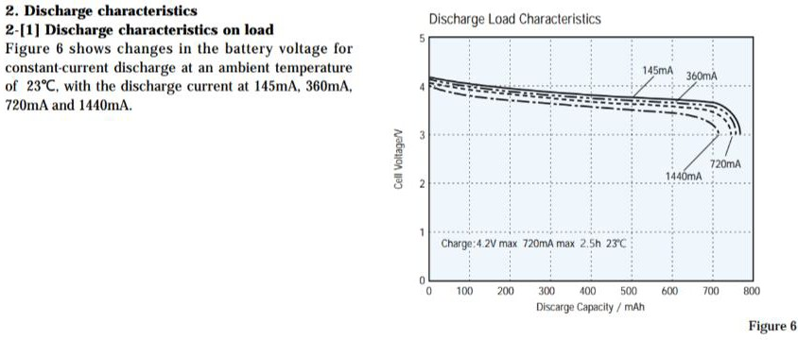

As charge/discharge cycles are repeated, the battery capacity (ability to hold a charge) gradually declines. However, when batteries are charged and discharged under the conditions recommended by Sony, they can be used for 500 or more charge/discharge cycles. The maximum voltage for charging is 8.4 V, and the cutoff voltage in discharge is 5 V (for hard carbon batteries) and 6.0 V (for graphite batteries with cobalt oxide cathode).

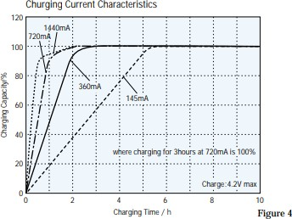

Maximum charging voltage is 4.2V and maximum charging current is 720mA. Battery’s peak current is 1.7 A and the peak current required by our system (Mode 4) is 138mA.

(Provide by LDO)

Maximum Minimum Operating Voltage: 1.8V Minimum Maximum Operating Voltage: 3.8V

### LOW POWER EMBEDDED DESIGN TECHNIQUES| ECEN 5833 | FALL 2019

The minimum voltage required for the system to function would be 5V since the barcode scanner only works if it is provided a rail voltage of 5V. This would be provided by the buck converter.

BULK CAPACITANCE

* + 1. Buck Regulator

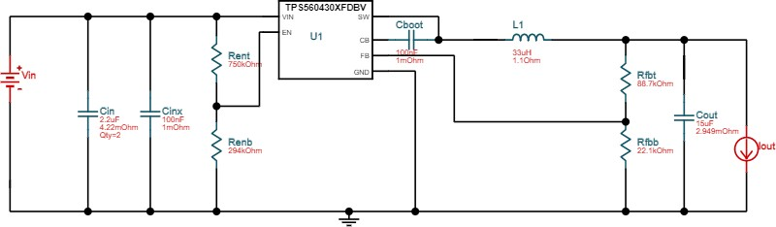

Above image is the circuit for buck regulator

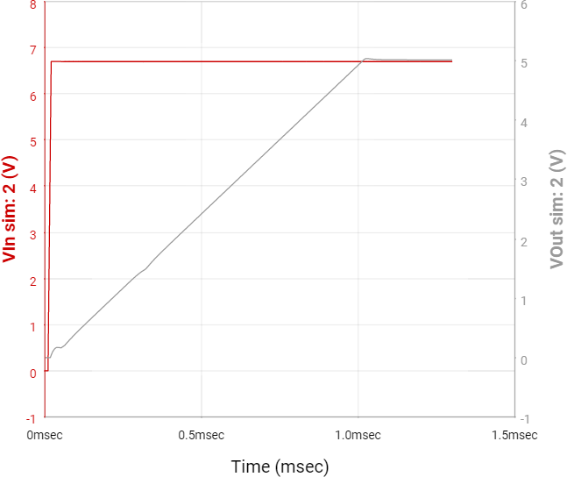

The above image is the startup graph i.e when the system boots.

### LOW POWER EMBEDDED DESIGN TECHNIQUES| ECEN 5833 | FALL 2019

LOAD TRANSIENT:

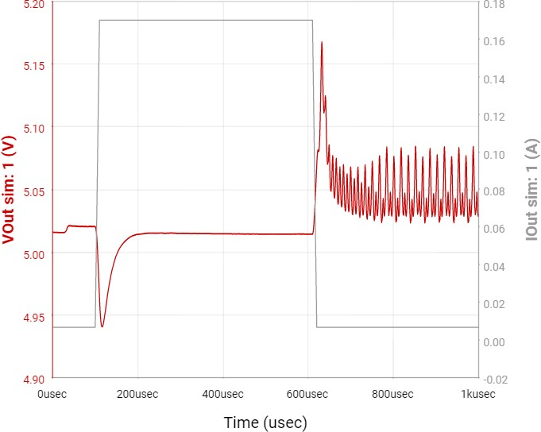

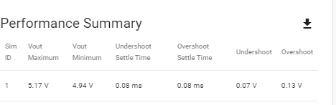

The minimum Vout is 4.94V which is well above the minimum requirement of 4.8V of the sensor.

The maximum Vout is 5.17 V which will be handled by the onchip AMS117 regulator in the barcode sensor.

Buck Capacitance = 15 uF (Part Number - KCM55LR71E156KH01)

### LOW POWER EMBEDDED DESIGN TECHNIQUES| ECEN 5833 | FALL 2019

At DC bias 5V, capacitance is 15.64 uF.

* + 1. 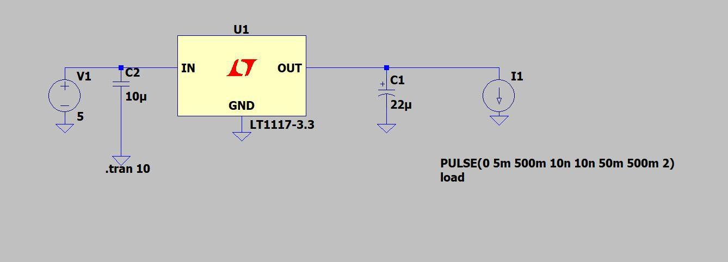LDO Regulator

Our Vin = min = max = 5V since the LDO is in series with the buck regulator.

At Vin = 5V

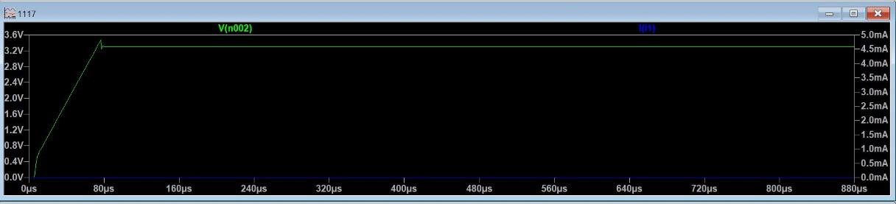

Capacitance chosen = 22 uF (Part Number - GRM32ER71C226KEA8) At DC bias 3.3V, capacitance is 22.61 uF.\

ENERGY STORAGE ELEMENT

The Energy Storage Element used would be a battery as specified in the component selection section.

|  |  |  |
| --- | --- | --- |
| **COMPONENT** | **ENERGY MODE** | **CURRENT(mA)** |
| NXP NTAG – NFC | I2C (Idle Mode) | 0.195 |
| I2C (Active Mode) | 0.24 |
| Barcode Scanner | Sleep Mode | 2 |
| Active Mode | 135 |
| Processor –  EFR32BG13 | EM2 (I2C) | 0.002 |
| EM1 (UART) | 3 |
| EM0 (Radio on) | 10 |

### LOW POWER EMBEDDED DESIGN TECHNIQUES| ECEN 5833 | FALL 2019

PROCESSOR:

Programming and Debugging

The silicon labs MCU and wireless starter kits provides a powerful development and debug environment. Debug capabilities include serial wire debug, JTAG, C2 interface, embedded trace microcell (EDM), advanced energy monitoring (AEM), packet trace interface (PTI), virtual comp port and virtual UART. All these features can be included by a 20 pin debug connector and a 20 pin simplicity connector provided on a WSTK can be used. For space constraint design, a mini simplicity connector is being used.

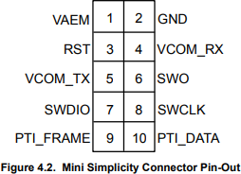

The mini simplicity connector has the following capabilities:

* SWD
* AEM
* PTI
* VCOMM

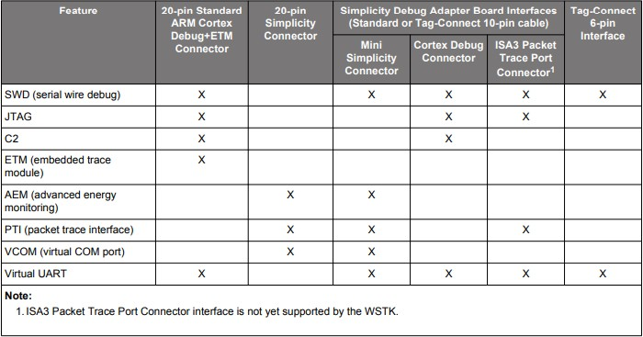

### LOW POWER EMBEDDED DESIGN TECHNIQUES| ECEN 5833 | FALL 2019

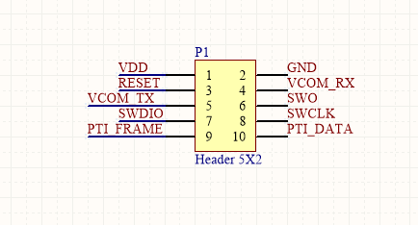

The above image is the connector to be used for programming and debugging. Reset Circuit Description:

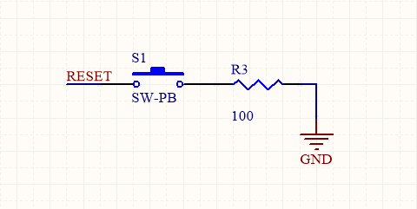

Taking the schematic design of silicon labs as a reference, the above image is the design for our reset pin. This pin is internally pulled up to AVDD. To apply an external reset source to this pin, it is required to only drive this pin low during reset, and let the internal pull-up ensure that reset is released.

### LOW POWER EMBEDDED DESIGN TECHNIQUES| ECEN 5833 | FALL 2019

Clock Generation Description:

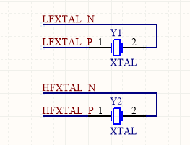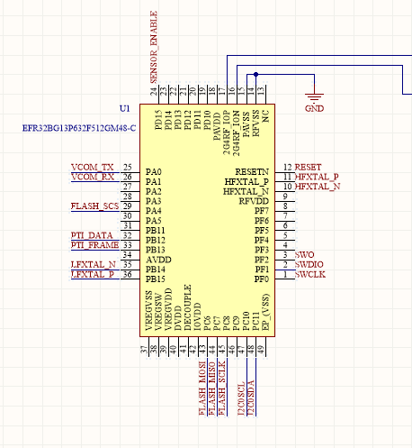

The two oscillators are namely: the Low Frequency Crystal Oscillator (LFXO) and the High Frequency Crystal Oscillator (HFXO). These oscillators require an external clock or crystal connected to the crystal oscillator pins of the device. However, no external crystal load capacitors are required as they contain on-chip tunable load capacitors. The LFXO supports

### LOW POWER EMBEDDED DESIGN TECHNIQUES| ECEN 5833 | FALL 2019

crystals with a nominal frequency of 32.768 kHz, while the HFXO supports 38.4 MHz. Both the high and low frequency clock sources can be used simultaneously.

LFXO part number: DST210A 1TJG125DP1A0012

LFXO load capacitance: 12pF

HFXO part number: 1ZZNAE38400AB0A HFXO load capacitance: 10pF

What is the maximum charging current allowed by the PMU circuitry?

ANS: Our battery has isolated charging pins and discharging pins. Hence our PMU has no interference with the charging current. Our battery management provides constant current/constant voltage to charge the battery. We have kept constant current as 500mA. It is possible to configure our constant current by changing the value of a single resistor

How much current will the programming of the MCU flash require?

* Write Current – 3.5mA
* Erase current – 2mA
* Supply voltage – 1.6V to 3.6V

How much current will the energy storage element and the PMU be able to provide? ANS: PMU is configured to provide currents upto 200mA.

What are the connection points to enable external power to digital / MCU portion of the board?

ANS: A switch would be provided in order to switch between an external supply and the onboard battery. The external supply would be a 5V USB port which will be connected to the Sensor and LDO. The Sensor has an onboard regulator, hence there is no requirement of using a regulator to regulate the voltage from the USB port.

What is the maximum charging current allowed by the energy storage unit? Ans: 1C mA = 1000mA.

What will be the maximum current of the JUMP START power source?

Ans: As per the battery specifications, we require 2-3 volts and few microamps per cell in order to JUMP START the battery.

Where will the with JUMP START and power ground signals connect to?

Ans: JUMP START and power signals will be connected to the input of THE PMU IC.

### LOW POWER EMBEDDED DESIGN TECHNIQUES| ECEN 5833 | FALL 2019

FIRMWARE ENVIRONMENT

* Simplicity Studio
* Blue Gecko
* NXP NTAG Explorer Kit
* Barcode Sensor
* MCP73213 Batter Charger Evaluation Board
* TPS560430 Evaluation Board

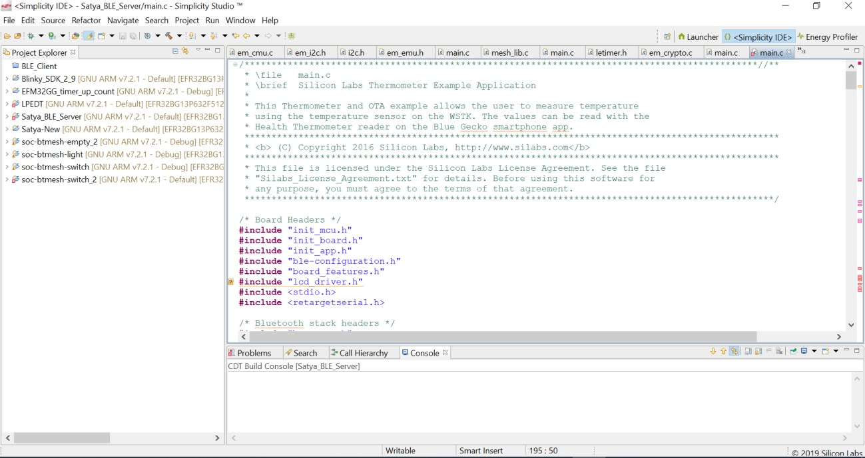

### LOW POWER EMBEDDED DESIGN TECHNIQUES| ECEN 5833 | FALL 2019

# USE CASE MODEL

**ENERGY MODES**

1. **Mode 1 - Deep Sleep Mode**

In deep sleep mode, the barcode sensor is powered down, NXP NTAG and the processor are in sleep mode. The idea behind this principle is that the device shouldn’t start scanning until it is connected to the phone. The power to the sensor is GPIO controlled, providing us the capability to turn if off when not in use.

NFC sleep current = 195uA EFR32BG13 Sleep mode = 2uA Total current in this mode = 197uA

1. **Mode 2 – Connection Initialization**

The NFC tag is triggered shifting into Active mode as specified in the table above using the Android app on the phone. This trigger will be used to turn on the radio and start Bluetooth advertising thus, switching the processor in EM0 mode (radio on). The authentication of Bluetooth is done using NFC. During this mode the sensor is powered down.

NFC active mode = 240 uA EFR32BG13 radio on = 10mA

Total current in this mode = 0.240mA + 10mA = 10.24mA After this mode the NFC would always be in idle state.

1. **Mode 3 – Connected Mode**

In this mode the barcode sensor is in sleep mode. The processor is in EM1 mode waiting for a successful read. Both the sensor and processor are in sleep mode.

Barcode Sensor Sleep Mode = 2mA EFR32BG13 EM1 Mode = 3mA

NFC Sleep Mode = 195uA

Total current = 2mA + 3mA + 0.195mA = 5.195mA

1. **Mode 4 – Product Scanning mode**

In this mode the barcode sensor scans the items and transfers data to the board using I2C interface.

Barcode sensor Active Mode = 135mA EFR32BG13 EM1 Mode = 3mA

### LOW POWER EMBEDDED DESIGN TECHNIQUES| ECEN 5833 | FALL 2019

NFC Sleep Mode = 195uA

Total Current = 135mA + 3mA = 138.195mA

1. **Mode 5 – Transmission Mode**

In this mode the Bluetooth radio communicates with the android app to send over the details of scanned items

EFR32BG13 radio on = 10mA Sensor Sleep Mode = 2mA NFC Sleep Mode = 195uA

Total current = 10mA +2mA = 12.195mA

**AVERAGE DC CURRENT MATH**

All the duration times considered in the following calculations are worst case scenarios.

1. **Connection Initialization Mode**

Time duration = 2 seconds

Considering 1 connection per hour with a consumption of 26mA current per connection Total Current Consumed = 26mA

1. **Product Scanning Mode**

Assuming the barcode scanner will successfully scan an item barcode in 1 second and considering 100 successful scans per hour with a consumption of 137mA current per scan.

Total Current Consumed = 138.195mA * 100 = 13819.5mA.

1. **Transmission Mode**

Assuming 1 second per transmission considering failed attempts and retries (worst case). Considering 100 successful transmissions per hour with a consumption of 12mA current per transmission.

Current Consumed = 12.195mA * 100 = 1219.5mA

1. **Connected Mode**

Being in connected mode without any data transmission for the remaining time i.e 1 hr –

time consumed in previous modes = 3397 seconds. sCurrent Consumed = 3398 * 5.195 = 17647mA

Average DC current in one hour = Total Current consumed in all modes/3600

= 9.08mA

### LOW POWER EMBEDDED DESIGN TECHNIQUES| ECEN 5833 | FALL 2019

Battery Capacity chosen = 1000mAh

Total operating hours in single full charge = Battery Capacity/9.08mA

= 1000/9.08 = 110.13 hours

Approximately 4-5 days of continuous operation for 24 hours with 100 scans per hours.

These calculations are for worst case scenarios. In order to have better continuous days of operation, better results can be achieved by reducing the current consumption in connected mode. In addition to this, energy harvesting methods can also improve the operating hours of the product.

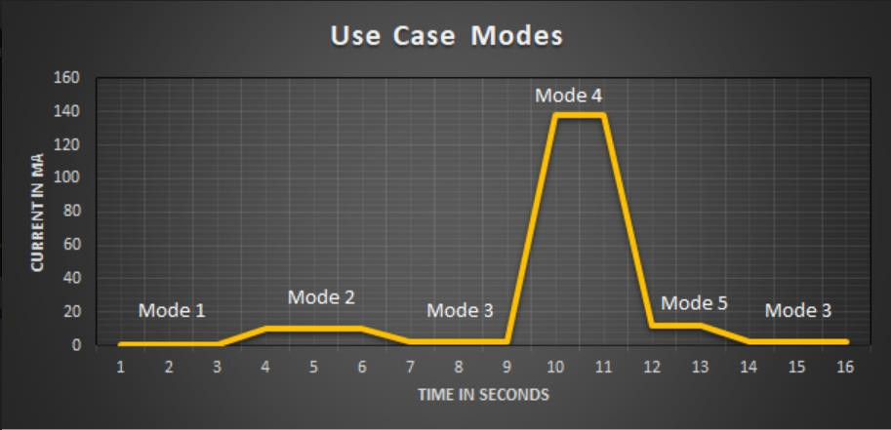

The above image represents our use case model broken into generic time slots showing current consumption for different phases of the system. The above graph is just an approximate representation of the energy modes that the entire system goes through.

Which signals will have test points?

* + External Adapter Supply voltage.
  + Input Voltage from the battery. (Vin)
  + Output Voltage from the buck (VDD) (5V)
  + Output voltage from the LDO (VCC) (3.3V)
  + Battery Management VREG (8.4V)
  + Buck Feedback Voltage (VFB)
  + Crystal Oscillators (LFXTAL, HFXTAL)
  + UART (TX, RX), I2C (SCL, SDA)
  + Ground Test Points at various places (GND)

### LOW POWER EMBEDDED DESIGN TECHNIQUES| ECEN 5833 | FALL 2019

* + Reset Pin.

Provide alternative charging method of the energy source other than the energy harvester. ANS: We will charge from an external 9V adapter. The Battery Management IC will take it as an input and supply 8.4V constant voltage and 500mA constant current to charge our battery.

# HIGH RISK DEVELOPMENT AREAS

1. NFC Implementation Failure: In case of failure of bluetooth pairing using NFC, we would shift to the basic just works method to pair the Bluetooth devices.
2. If we are not able to design an inverted F-antenna in the expected time frame, since the reference design is a 4 layer design and we are expected to design a 2 layer PCB, we would be having a provision to directly connect a Bluetooth module (BGM11).

# FUTURE SCOPE

* + Budget Alert feature where the app notifies the user about budget limit crossed.
  + Load cell can be incorporated for the items which has to be purchased in weight rather than in quantity.
  + We can analyze the data for stock and asset management.
  + Secured automatic payment through the android application.